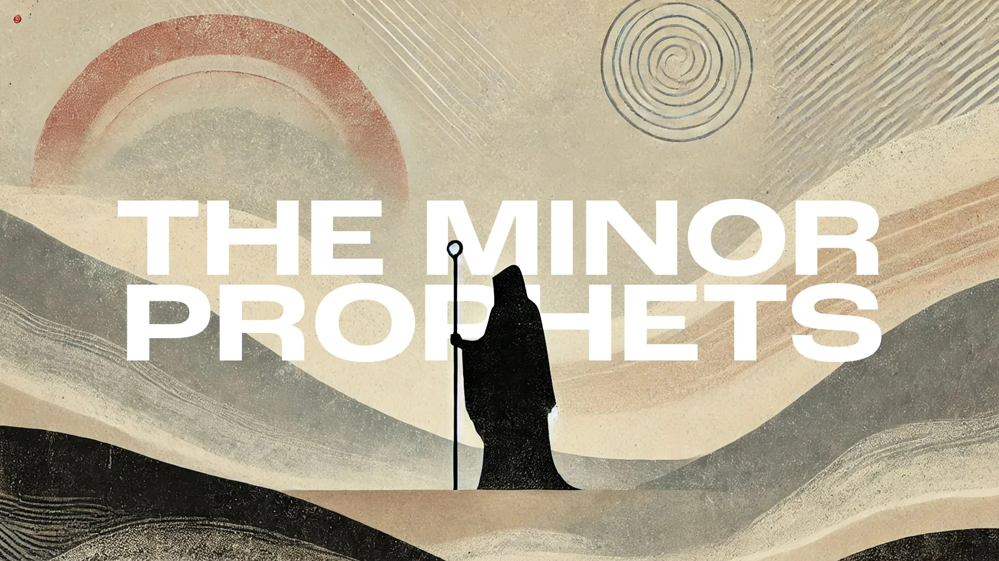
Victory Fellowship Bible Study
273 23rd St. S.W., Barberton, OH 44203
Wednesdays at 7pm
Rev. Roderick D. Grabski (330) 858-0223
arod4God@neo.rr.com FACEBOOK: Roderick Grabski

CLASS Seven: I Am God, Not Man
- ANNOUNCEMENTS and PRAYER CONCERNS

- READ / LISTEN to Hosea 11:1-12
  - What are your initial impressions? Notable translation differences?

- AI - Chapter 11 Summary

- The Lord’s Love for Israel (11:1-12)
  - (vv. 1-4) Note and discuss how the Lord alternates between “I did this” and “but “Israel did that.”

  - (vs. 4) When the Lord says He “bent down” is means He was gentle.

  - (vv. 5-7) Verse 5 may be a rhetorical question. The Lord is announcing His penalty for Israel’s ingratitude.

  - (vv. 8-11) The drastic change of emotion in these verses shows us God’s grace on full display. (See Genesis 14:8 and Deut. 29:23 for Admah and Zeboiim.)

  - (vs. 12) Ephraim and Judah were grieving the Lord. The Hebrew word for God here is El, not Elohim. It may be a reference to the Canaanite god. Holy ones can be angels or godly people but in this context it may be referring to Canaanite deities and/or cult prostitutes.
    - In the Hebrew bible this verse is not 11:12 but 12:1.

- READ / LISTEN to Hosea 12:1-14
  - What are your initial impressions? Notable translation differences?

- AI - Chapter 12 Summary

- God’s Case Against the Heirs of Jacob (12:1-8)
  - (vs. 1) In pursuing alliances, Israel is playing with fire. (2Kings 18:19-25)

  - (vv. 2-5) Comparing Jacob, who found God at Bethel, Hosea rebukes Israel for finding Baal at Bethel (Beth-aven).

  - (vs. 6) What 3-fold repentance does Hosea call for?

  - (vs. 7) The Hebrew word for merchant is Canaan. Thus Israel is described as a Canaanite. They practice what God forbids. (Lev. 19:36)

  - (vs. 8) In their arrogance Ephraim does not see their sin.

- Judgment on Rebellious Israel (12:9-11)
  - The Festival of Booths (Lev. 23:34, 41-43) allowed Israel to remember God’s saving acts, including reliving the wilderness experience of living in tents. Hosea declared that this will become their permanent dwelling. Their pagan altars will be reduced to a heap of rocks.

- Further Indictment of Jacob’s Heirs (12:12-14)
  - (vv. 12-13) Like verse 4 Hosea relates to Jacob again. This time describing Jacob as too poor to afford a bride price and ultimately shepherding flocks, whereas the Hebrew people were formerly led out of Egypt by a shepherd (Moses) who was a prophet.

  - (vs. 14) Their worship of Baal was bloodguilt (or murder) because it was a capital offence.

- READ / LISTEN to Hosea 13:1-16
  - What are your initial impressions? Notable translation differences?

- AI - Chapter 13 Summary

- Indictment of Jacob’s Heirs Continues (13:1-3)
  - (vs. 1) In the days of King Jeroboam II (2Kings 14:26-27) the Northern Kingdom expanded its territory and other nations trembled in fear. That is now no longer the case.

  - (vv. 2-3) By repeatedly violating God’s Law (Exodus 34:17) they brought down upon themselves the curse from Deuteronomy 27:15. The word sacrifice is referring to human sacrifice.

- Death and Resurrection (13:4-14)
  - (vv. 4-6) God recalls His presence in the wilderness experience. In verse 5 the Hebrew word, hbwalt tal'uwbah, is only found here in the Hebrew bible and is translated drought or burning heat. Their prosperity led them to forget God.

  - (vv. 7-9) What are your thoughts about this description of God?

  - (vv. 10-13) There is now no king to save Israel.

  - (vs. 14) What an amazing reversal. God’s power eliminates the sting of death.

- The Coming Judgment (13:15-16)
  - “Brothers” probably refers to their alliances with other nations. Everything they relied upon will disappear. The rebellious Israel will be victimized by an army with no moral restraints.

- APPLICATION:
  - Repenting and turning to God is the only hope for a sinful nation or individual. (Acts 2:38)

  - Invite God into every area of your life and not just for emergencies to get you out of trouble. (Luke 10:27)

  - Worship and serve the Lord as the only true, living God of the universe. (Psalm 95:6-7)

- Final Comments, Questions. Close in Prayer

Next Week: Return to the Righteous One - Read Hosea 14:1-9 to prepare.

