VICTORY FELLOWSHIP ANNOUNCEMENTS (week of November 1, 2026)

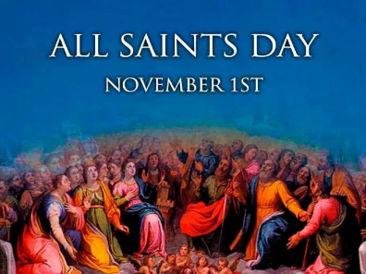
WELCOME EVERYONE! We are glad you are here today!

Restrooms are located downstairs on the left side of the hallway. There is a diaper changing table downstairs in the 2nd restroom on the left, at the end of the hallway (Men’s room).
We have a child’s potty seat in the women’s restroom. We also have a mommy rocking chair downstairs.
 Feel free to help yourself to water, coffee, or tea from our hospitality table. Please use the cup lids to prevent spills in the Sanctuary. Thank you!

COPYRIGHT / STREAMING LICENSE: Victory Fellowship holds copyright and streaming licenses (CCLI #11286647 & #21085139) that permits us to play music, reproduce song lyrics and hymnal music for bulletin inserts, song books, PowerPoint presentations, and overhead projection. We are also licensed to broadcast the music and PowerPoint presentations from our services on live-stream.
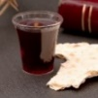 We believe that our Lord Jesus Christ invites to the Communion table anyone who loves Him, who is repentant of their sin, and who desires to live peacefully with one another. You do not have to be a member of our church to take communion with us. There is no age or membership restriction. Parents and guardians can be the judge on whether your children know Jesus and understand these concepts.

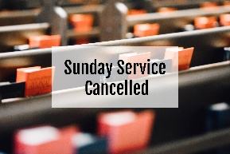 Church service for Sunday, November 15th will be cancelled.
 The ACME Community Cash Back program runs from Aug, 1, 2026 – Feb. 15, 2027. We receive 5¢ of every dollar collected toward a minimum goal of $1500. We have about $276 in receipts so far. Thank you.
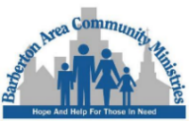 Victory Fellowship participates in the Barberton Area Community Ministries monthly donation needs. For the month of NOVEMBER we will be collecting Peanut Butter, Breakfast Items, and Dish soap. We also collect toiletries, paper and plastic bags. Thank you!
 Victory Fellowship BIBLE STUDY meets on Wednesdays at 7pm with a study of the Minor Prophets. Attend in person or watch on Facebook or victoryfellowshipministries.com.
 We donate the cash collected in the blue jar to the Esther Ryan Shoe Fund. We have sent $2686 to date!

OFFERING ENVELOPES and PRAYER REQUEST CARDS are provided for your convenience in a rack at the Welcome Center area as you enter the church. If you are a First Time guest, please do not feel any obligation to participate in the offering.
 If you can’t be here in person, you can now give to our church online or from a mobile app when you are out of town or on vacation.
 At Victory Fellowship we practice laying on of hands, prayer, and anointing with oil for concerns that need God’s healing intervention. YOU MAY REQUEST OIL ANOINTING AND PRAYER AT ANY TIME.
 Christopher Wagar volunteers for the ministry of mowing our lawn.
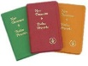 Please consider using the GIDEONS CARD RACK in the Welcome Area to send cards to friends and relatives. Not only will you be encouraging them, you will be sending God’s Word around the world.
 We are in the Bible App. Follow along. Take Notes. Reference the bible.

Please see Pastor Rod for the Wi-Fi password if you would like to use your wireless devices in the building.

VICTORY FELLOWSHIP CONTACT INFO:
Mailing Address: 273 23rd St. S.W., Barberton, OH 44203
Rev. Roderick D. Grabski, Founding Pastor
Pastor’s Cell phone: 330-858-0223 (leave a message)
Email: arod4God@neo.rr..com
Watch our services and bible study live on our Webpage: victoryfellowshipministries.com or on
- FACEBOOK: Roderick Grabski or Victory Fellowship

1st John 5:4 For every child of God defeats this evil world, and we achieve this victory through our faith.

1st Corinthians 15:57 But thank God! He gives us victory over sin and death through our Lord Jesus Christ.

