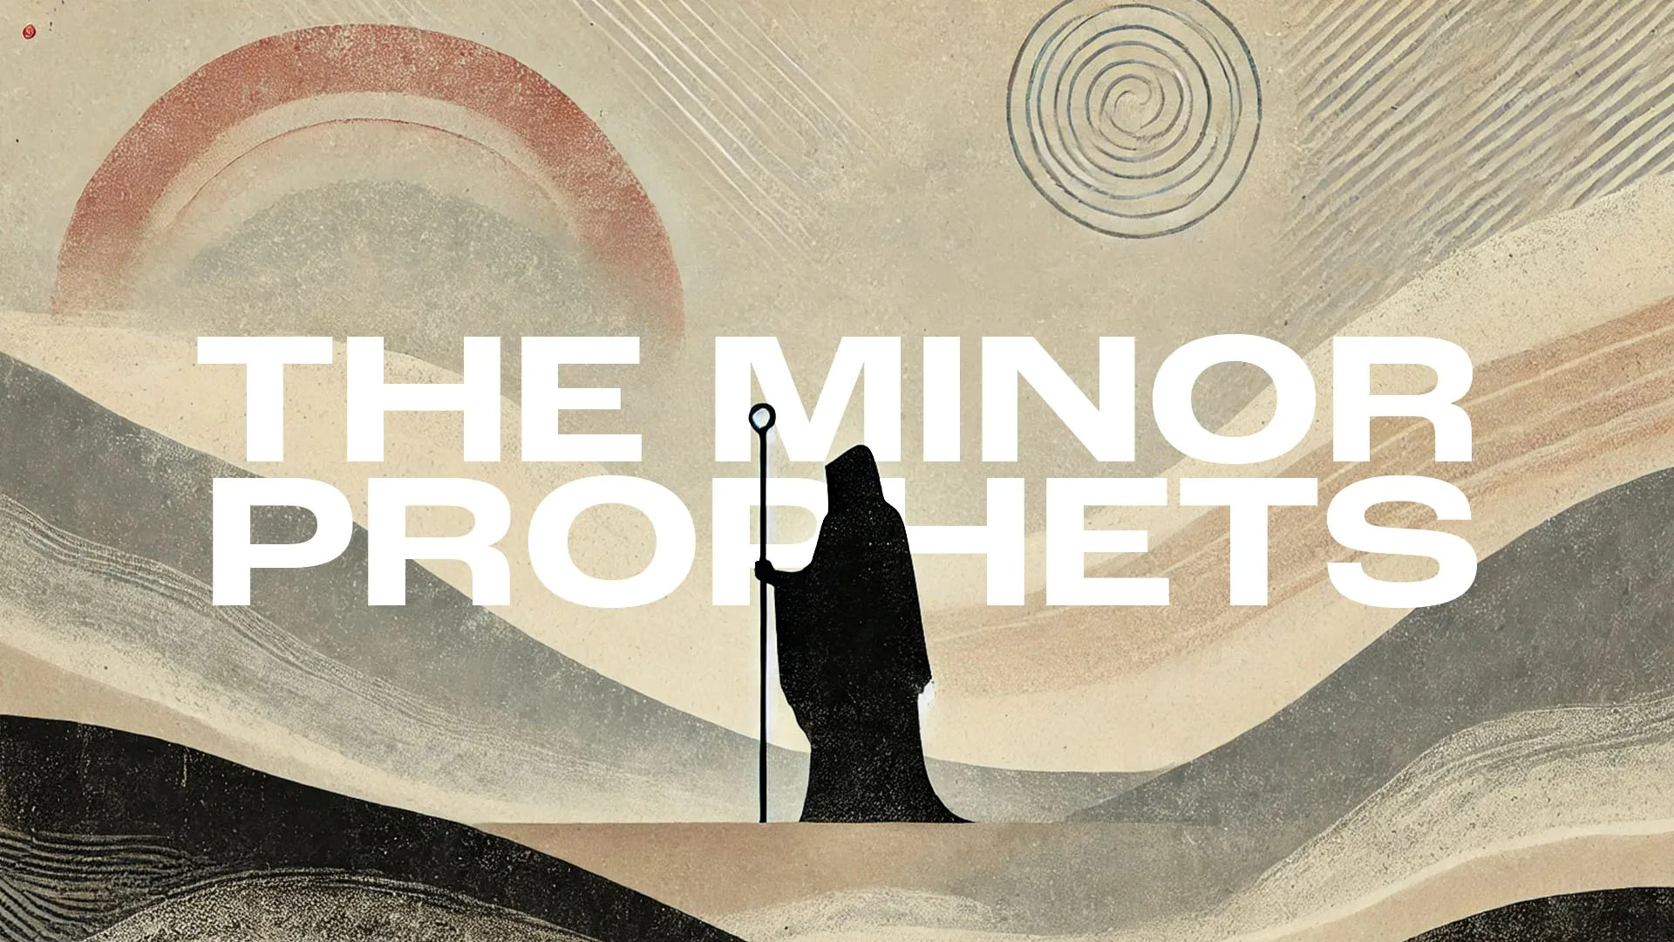
Victory Fellowship Bible Study
273 23rd St. S.W., Barberton, OH 44203
Wednesdays at 7pm
Rev. Roderick D. Grabski (330) 858-0223
arod4God@neo.rr.com FACEBOOK: Roderick Grabski

CLASS Six: The Lord No Longer Loves
- ANNOUNCEMENTS and PRAYER CONCERNS

- READ / LISTEN to Hosea 8:1-14
  - What are your initial impressions? Notable translation differences?

- AI - Chapter 8 Summary

- God is Speaking in Chapter Eight.
  - (vv. 1-3) Blow the horn!

  - (vv. 4-6) The idol is destroyed. Samaria is a reference to the entire northern kingdom.

  - (vv. 7-10) They will reap what they sow.

  - (vv. 11-14) Israel and Judah will be punished.

- READ / LISTEN to Hosea 9:1-17
  - What are your initial impressions? Notable translation differences?

- AI - Chapter 9 Summary

- Hosea is Speaking in 9:1-9
  - (vv. 1-3) The exile to Egypt and Assyria is coming.

  - (vv. 4-6) There will not be enough food to offer sacrifices. Memphis will bury them is a foretelling of the exodus in reverse.

  - (vv. 7-8) Their actions have brought punishment.

  - (vs. 9) They have corrupted themselves. (Genesis 6:11-12)

  - (vv. 9:9 & 10:9) Listen to Judges 19:1-20:11 on Gibeah.

- God is Speaking again in 9:10-17
  - (vs. 10) God recalls His initial pleasure with Israel. But they loved Baal (Shame).

  - (vv. 11-14) They will be made barren. Even the children that are conceived will not survive. Their children born will not survive.

  - (vv. 15-17) Gilgal was Israel’s 1st worship center in the Promised Land.
- READ / LISTEN to Hosea 10:1-15
  - What are your initial impressions? Notable translation differences?

- AI - Chapter 10 Summary

- Hosea is Speaking again in 10:1-8
  - (vv. 1-2) The more they prospered, the more idolatrous they became.

  - (vv. 3-4) The original “no kings” protest.

  - (vv. 5-8) Their own idols invoke fear and destruction. See 1Kings 12:28-30

  - (vv. 9-10) God will bring discipline.

  - (vv. 11-12) No more “easy row to hoe.”

  - (vv. 13-15) War is coming.

- APPLICATION:
  - Our walk of faith must align with our confession (or talk) of faith. (James 2:17; 1 John 1:6-7)

  - Our political views, actions, and commitments should meet God’s standard of righteousness and expectations, not the world’s. (James 4:4; 1 John 2:15-16)

  - Our life goals should align with God’s command for faithful love, righteousness, and loyalty. (Deuteronomy 10:12; Micah 6:8)

- Final Comments, Questions. Close in Prayer

Next Week: I Am God, Not Man
- Read Hosea 11:1 - 13:16 to prepare.

