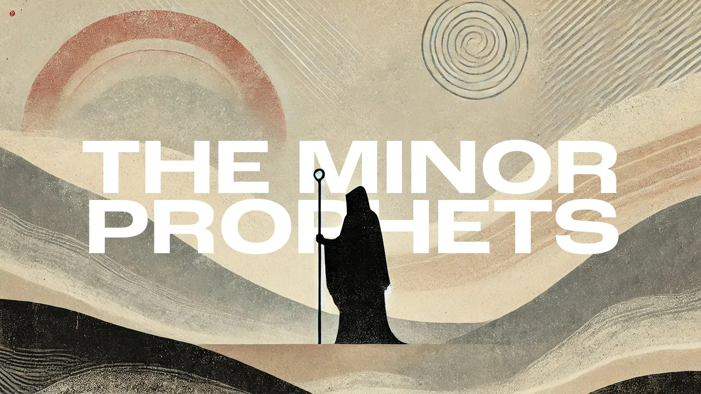
Victory Fellowship Bible Study
273 23rd St. S.W., Barberton, OH 44203
Wednesdays at 7pm
Rev. Roderick D. Grabski (330) 858-0223
arod4God@neo.rr.com FACEBOOK: Roderick Grabski

CLASS ONE: Introduction / Overview of The Minor Prophets
- ANNOUNCEMENTS and PRAYER CONCERNS

- Review Course Content
Mention Offering Envelopes and Go over Tentative Class Schedule

- COURSE OBJECTIVES
      - To Glorify God in our study of His Word - with the understanding that the Old Testament is God’s Inspired Word. (2 Timothy 3:16)
      - To Edify our own knowledge and understanding.
      - To Outline and Study the Historical Context of The Minor Prophets
      - To Understand the Practical Application for our life situation.
      - To Comprehend God’s choosing of individual persons to implement His plans.
      - To Praise God for His fulfillment of prophetic promise.

- Timeline of DIVIDED KINGDOM Kings and Prophets
  - The Prophets 860-430 B.C.

  - Divided Kingdom Judah & Israel’s Kings

  - Timeline Chart

- Overview of the Twelve Minor Prophets

- Major Themes in the Minor Prophets
  - Repentance, Justice, God’s Holiness, God’s Mercy, Restoration,
The Kingdom of God, God’s Purpose for the Nations, Messianic Hope

- APPLICATION:
  - We won’t study the Minor Prophets only for their predictions. We will also study their historical content, understand their original message, follow their theological content, and seek to apply their timeless principals.

- Final Comments, Questions. Close in Prayer

Next Week: Impossible Love Affair - Read Hosea 1:1 - 2:1 to prepare.

The content of this course, and the instructor, rely heavily upon a traditionally high view of Scripture whereby the Bible (both Old and New Testament) is understood as the Word of God that is Inspired, Infallible, and Inerrant in the original sources. The Whole Bible contains all that is necessary for our Salvation and is the final authority for ethical and moral matters in the life of the believer and unbeliever alike.

