VICTORY FELLOWSHIP
WORSHIP TO ALMIGHTY GOD
January 12, 2025 - 11am – Baptism of the Lord

SONG OF WELCOME: He is Lord
PRELUDE / MINISTRY OF ACOLYTES

Call to Worship: 1 Thess. 5:2-5, 8-11, 23 NASB

SONG OF PRAISE: Everlasting Arms

GREETINGS & ANNOUNCEMENTS
4th Quarter & Year-end 2024 Financial Reports

PRAYER REQUESTS
From the COMMUNITY of FAITH
(You are welcome to join Pastor Rod at the altar during prayer)

Call to Prayer: Seek Ye First (vs. 1)

PASTORAL PRAYER OF INTERCESSION

Response: Seek Ye First (vs. 3)

CHILDRENS MESSAGE: Win with Jesus

SCRIPTURE READING: John 16:28-33 NKJV

OUR TITHES & OFFERINGS
DOXOLOGY:
Praise God, from Whom All Blessings Flow #622

SONG OF REFLECTION: Lord I Need You

SACRAMENT OF HOLY COMMUNION:
(We all take at the same time–first the bread, then the cup)

WORDS OF REMEMBRANCE
PRAYER OF THANKSGIVING
GIVING THE BREAD / GIVING THE CUP
PASSING THE PEACE OF CHRIST

PASTOR ROD PROCLAIMING GOD’S WORD

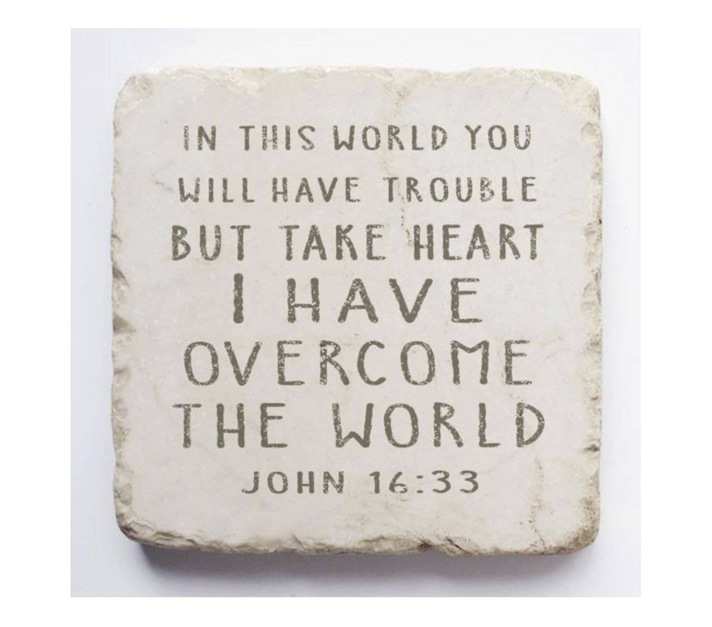

SONG OF GOING FORTH: He Is
MINISTRY OF ACOLYTES
BLESSING OUR GOING FORTH

Thank you to these Worship Servants:
Piano / Keyboard: Tesia Wagar
Greeter(s): Clarence Carr
Scripture Reader(s): Jaime Grabski
Acolyte: Sammy Grabski
Communion / King’s Kids: Jaime Grabski
Ushers: Terry & Julie Carr / Clarence Carr / Chris Wagar
Samuel Grabski / Zach Earnsberger
Tech Engineer: Chris Wagar
(January 12, 2025) PRAYER CONCERNS:
PRAYER REQUEST CARDS ARE PROVIDED IN A RACK AT THE WELCOME CENTER AREA AS YOU ENTER THE CHURCH. PLACE THE REQUEST CARD IN THE OFFERING PLATE WHEN IT IS PASSED.

PERSONS: Anyone dealing with any type cancer,
Anyone mourning the loss of a loved one, Neil Carr,
Joyce Lacey, Crystal Cales, Sandy Dreurey, Alan Ash, Nickolas, Hunter, and Aiden Skiffey, Keith & Delores Carr,
Bonnie Cottrell, Dave Wells, George Ulichney, Flo Rhodes, Pastor Rod, Sue Garrard, Gary Johnson, Laura Jacks, Sherry Lacey, Mary Duncan, Haille Riddle, Paula Maynard Lynn,
Brandi Dewalt.

For Parents Tiffany & Kyle Forsythe and their unborn baby due in March 2025; for Parents Laura & Bryon Grabski and their unborn baby girl due in June 2025.

PRAY for our MILITARY and FIRST RESPONDERS.
Pray for the Persecuted Church in the World,
Pray for the Peace of Jerusalem and ISRAEL (Psalm 122:6-9),
Pray for the Unborn, and for The Gideons International
Pray for the new and emerging GMC (Global Methodist Church)

SITUATIONS: Pray for God’s Favor for Victory Fellowship. Pray for our Nation’s and the World’s Leaders; For our City; For Victims of Hurricanes, Earthquakes, Fires, Storms, Mudslides, Floods; For Unemployed and/or the homeless; For Public school safety; For those affected by acts of violence; Pray against the Drug epidemic.

VICTORY FELLOWSHIP CONTACT INFO:
Mailing Address: 273 23rd St. S.W., Barberton, OH 44203
Rev. Roderick D. Grabski, Founding Pastor
Pastor’s Cell phone: 330-858-0223 (leave a message) Watch our services and bible study live on our Webpage: victoryfellowshipministries.com
Follow on FACEBOOK: Roderick Grabski or Victory Fellowship

