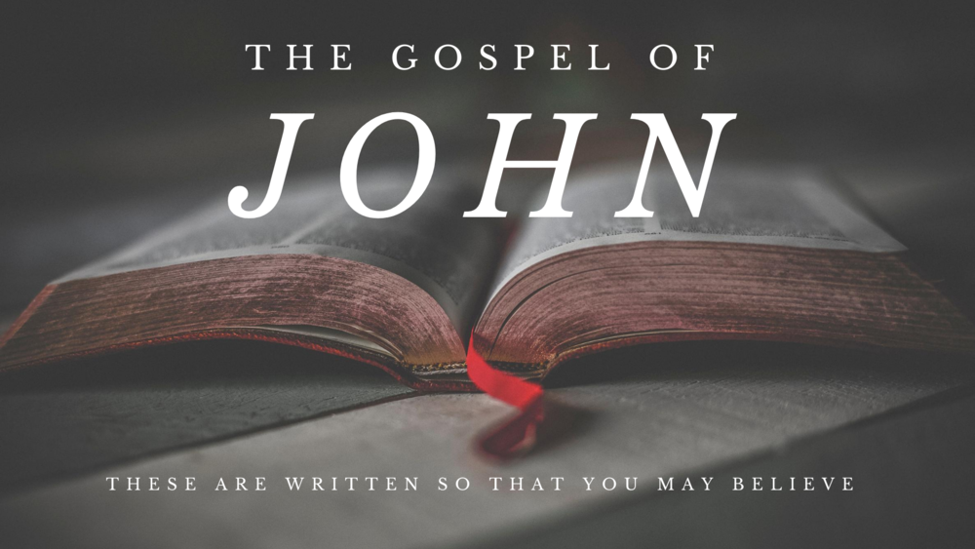

**Victory Fellowship Bible Study**

**273 23rd St. S.W.**, Barberton, OH 44203

Wednesdays at 7pm

***Rev. Roderick D. Grabski*** (330) 858-0223

**WEBPAGE:** [**victoryfellowshipministries.com**](mailto:arod4God@neo.rr.com)

[**arod4God@neo.rr.com**](mailto:arod4God@neo.rr.com) FACEBOOK: Roderick Grabski

***CLASS SIX: The 3rd Sign: Healing the Sick***





1. **ANNOUNCEMENTS and PRAYER CONCERNS**
2. **Read / Listen to John 5:1-47**
   1. What are your initial impressions or questions?

Notable translation differences?

1. **The 3rd Sign - Healing the Sick (vv. 1-15)**
   1. The Hebrew word *Bethesda* has various spellings (Bethsaida, Bethzatha) and may mean “house of mercy” or “house of grace.”
   2. (vv. 3-4) Compare various translations of these verses.
   3. (vv. 5-9a) Similar healings are recorded in Matthew 9; Mark 2, and Luke 5. Here in John 5 does the man express faith in Jesus?
   4. (9b-13) The man did not violate a biblical Sabbath regulation, but rather a rabbinical code that prohibited carrying an object from one dwelling to another.
   5. (vv. 14-15) What is your perspective on this encounter? What do you think is the “something worse” Jesus is referring to?
2. **Honoring the Father and the Son (vv. 16-23)**
   1. (vv. 16-18) Note the two main things that Jesus was doing that were most disturbing to the Jews.
      1. Jesus did ***instantly*** what the Father is always doing slowly.
   2. (vs. 19) Compare with Numbers 16:28.
   3. (vv. 20-23) Jesus is equating himself with God and establishing His right to be worshiped as God. (Dt. 32:39; 1Sam 2:6; 2Kg 5:7)

1. **Life and Judgment (vv. 24-30)**
   1. Compare with Daniel 12:1-4; Matthew 25:31-46; 1st Cor. 15:51-58; 1st Thessalonians 4:13-18; Revelation 20:11-15.
   2. “The Son of Man” is used 12 times in John and over 80 times in the four Gospels. See Daniel 7:13-14.
2. **Four Witnesses to Jesus (vv. 31-47)**
   1. (vs. 31) Jesus is not denying His reliability. He is alluding to the importance of multiple witnesses (Dt. 17:6; 19:15; Numbers 35:30)
   2. (vv. 32, 37) Who is Another who testifies about Jesus?
   3. (vv. 33-35) Who is the witness mentioned here?
      1. Compare translations of verse 35. John was a lamp – not the light.
   4. (vs. 36) How is Jesus’ testimony greater than John’s?
   5. (vv. 38-44) What are the accusations being made here?
   6. (vv. 45-47) See Deuteronomy 31:24-30 for a reference.
      1. Jesus’ appeal to Moses prepares the way for chapter 6 where Jesus is presented as the new Moses, providing new bread from heaven.
3. **Application**
   1. Spoken or unspoked church rules, or denominational requirements, that are not founded on the Word of God can hinder the work of God and Christian growth. (Hosea 6:6; Matthew 12:7)
   2. Every soul will be resurrected to an eternal fate – either life with God or an eternal judgment. (Daniel 12:2; Matthew 25:46)

**Final Comments, Questions. Close in Prayer**

**Next Week:**

***The 4th Sign: Feeding 5000 / 5th Sign: Walk on Water***

- Read John 6:1-29 to prepare.

