VICTORY FELLOWSHIP
WORSHIP TO ALMIGHTY GOD
October 20, 2024 - 11am

SONG OF WELCOME: The Family of God

PRELUDE / MINISTRY OF ACOLYTES

CALL TO WORSHIP: Psalm 31:1-5 NLT

SONG OF PRAISE: Lord of All

GREETINGS & ANNOUNCEMENTS

PRAYER REQUESTS
From the COMMUNITY of FAITH
(You are welcome to join Pastor Rod at the altar during prayer)

Call to Prayer: Lord Have Mercy, Christ Have Mercy

PASTORAL PRAYER OF INTERCESSION

Response: Glory Be to the Father #615

CHILDRENS MESSAGE: Laugh

SCRIPTURE READING: Acts 12:11-17 NLT

OUR TITHES & OFFERINGS
DOXOLOGY:
Praise God, from Whom All Blessings Flow #622

SONG OF REFLECTION: This Road

SACRAMENT OF HOLY COMMUNION:
(We all take at the same time–first the bread, then the cup)

WORDS OF REMEMBRANCE
PRAYER OF THANKSGIVING
GIVING THE BREAD / GIVING THE CUP
PASSING THE PEACE OF CHRIST

PASTOR ROD PROCLAIMING GOD’S WORD
Funny How God Works
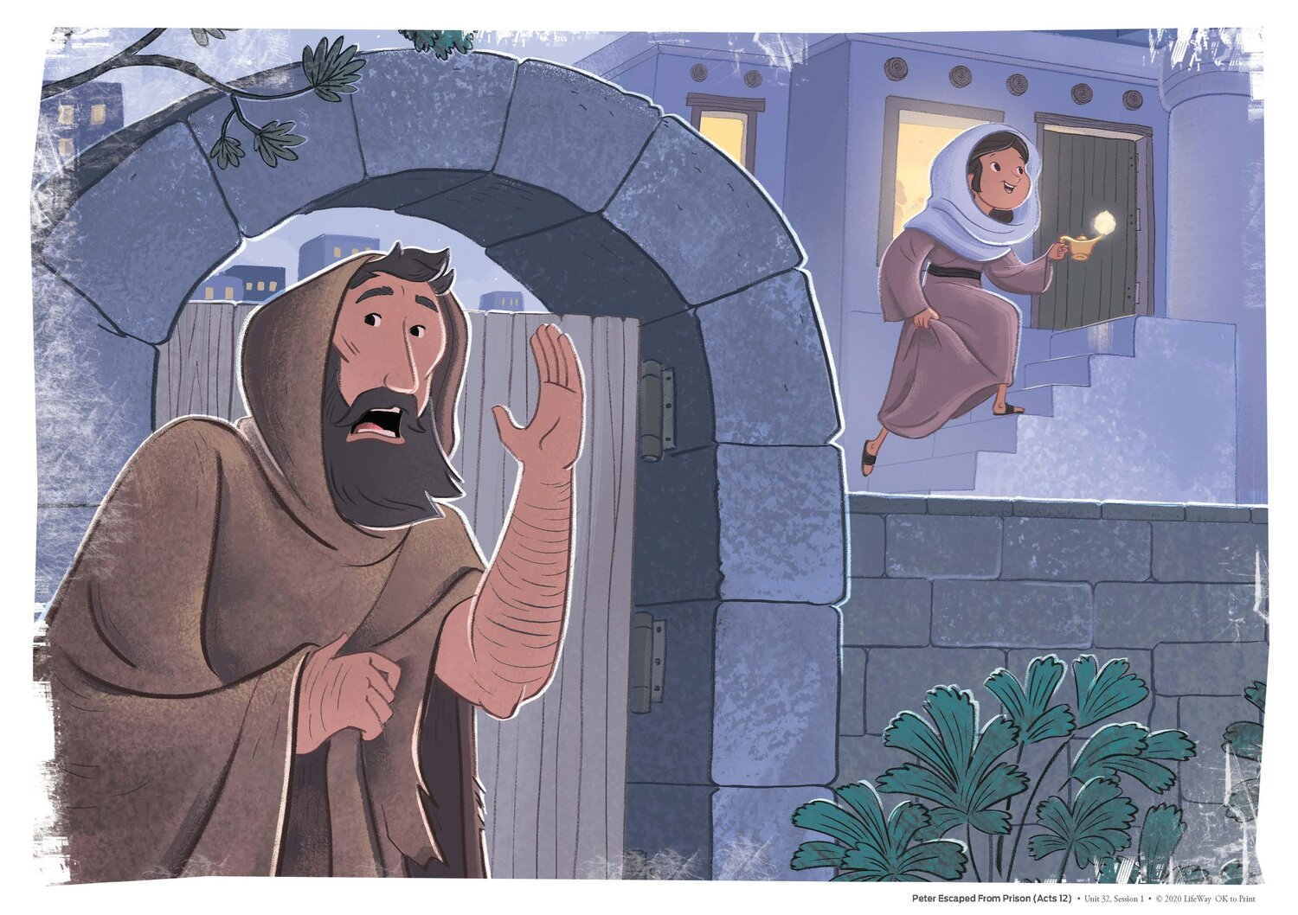
SONG OF GOING FORTH: My Deliverer
MINISTRY OF ACOLYTES
BLESSING OUR GOING FORTH

Thank you to these Worship Servants:
Piano / Keyboard: Tesia Wagar
Greeter(s): Clarence Carr
Scripture Reader(s): Jaime Grabski
Acolyte: Sammy Grabski
Communion / King’s Kids: Jaime Grabski
Ushers: Terry & Julie Carr / Clarence Carr / Chris Wagar
Samuel Grabski / Zach Earnsberger
Tech Engineer: Chris Wagar
(October 20, 2024) PRAYER CONCERNS:
PRAYER REQUEST CARDS ARE PROVIDED IN A RACK AT THE WELCOME CENTER AREA AS YOU ENTER THE CHURCH. PLACE THE REQUEST CARD IN THE OFFERING PLATE WHEN IT IS PASSED.

PERSONS: Anyone dealing with any type cancer,
Anyone mourning the loss of a loved one, Jaime’s travel, Beth Beddow, Joyce Lacey, Sandy Dreurey, Alan Ash, Nickolas, Hunter, and Aiden Skiffey, Keith & Delores Carr, Bonnie Cottrell, Dave Wells, George Ulichney, Flo Rhodes, Penny Livingston, Sue Garrard, Gary Johnson, Laura Jacks, Sherry Lacey, Tom & Deb Haines, Gideon & Evie Merton, Emma Pfouts, Mary Duncan, Haille Riddle, Pastor Rod,
Paula Maynard Lynn, Kathy Hutnick, Brandi Dewalt.

Pray for Parents Megan & Stephen Baglia and their unborn baby due in December 2024.

PRAY for our MILITARY and FIRST RESPONDERS.
Pray for the Persecuted Church in the World,
Pray for the Peace of Jerusalem and ISRAEL (Psalm 122:6-9),
Pray for the Unborn, and for The Gideons International
Pray for the new and emerging GMC (Global Methodist Church)

SITUATIONS: Pray for God’s Favor for Victory Fellowship. Pray for our Nation’s and the World’s Leaders; For our City; For Victims of Hurricanes, Earthquakes, Fires, Storms, Mudslides, Floods; For Unemployed and/or the homeless; For Public school safety; For those affected by acts of violence; Pray against the Drug epidemic.

VICTORY FELLOWSHIP CONTACT INFO:
Mailing Address: 273 23rd St. S.W., Barberton, OH 44203
Rev. Roderick D. Grabski, Founding Pastor
Pastor’s Cell phone: 330-858-0223 (leave a message) Watch our services and bible study live on our Webpage: victoryfellowshipministries.com
Follow on FACEBOOK: Roderick Grabski or Victory Fellowship

