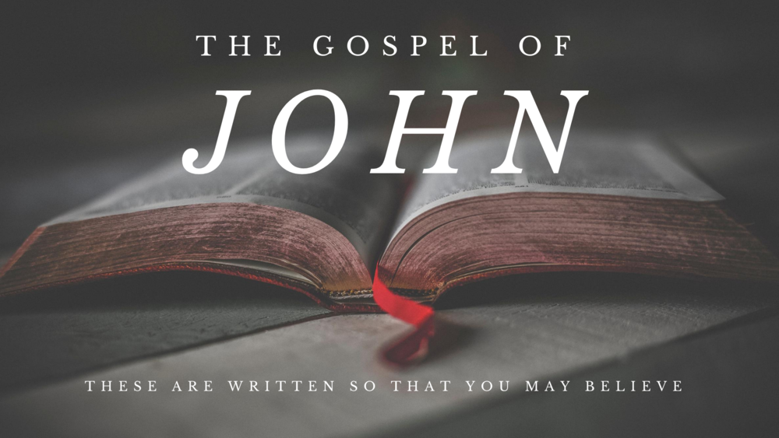

**Victory Fellowship Bible Study**

**273 23rd St. S.W.**, Barberton, OH 44203

Wednesdays at 7pm

***Rev. Roderick D. Grabski*** (330) 858-0223

**WEBPAGE:** [**victoryfellowshipministries.com**](mailto:arod4God@neo.rr.com)

[**arod4God@neo.rr.com**](mailto:arod4God@neo.rr.com) FACEBOOK: Roderick Grabski

***CLASS FOUR: Jesus & Nicodemus: The New Birth***





1. **ANNOUNCEMENTS and PRAYER CONCERNS**
2. **Read / Listen to John 3:1-36**
   1. What are your initial impressions or questions?

Notable translation differences?

1. **Jesus and Nicodemus (vv. 1-21)**
   1. (vs. 1) What all do we learn about Nicodemus from this verse?
   2. (vs. 2) What reasons might Nicodemus have for wanting to see Jesus at night?
   3. Nicodemus says, “*we know*…” Who are “*we*?” Is Nicodemus sincere?
   4. (vs. 3) Jesus uses the plural “*you*.” The Greek word for “*again*” is **anwqen** *anothen*. It can be translated as *again* or *from above*, or *from the top*.
      1. See Matthew 27:51; Mark 15:38; John 3:31; 19:11, 23; Galatians 4:9; and James 1:17; 3:15, 17
   5. (vs. 4) Based on his response, what does Nicodemus think Jesus means?
   6. (vs. 5) What do you think “born of water and the spirit” means?
      1. Consider Ezekiel 36:25-27; Ephesians 5:25-27; Titus 3:5; James 1:18; and 1st Peter 1:23-25
   7. (vv. 6-8) What is the simple, yet profound message Jesus is giving?
   8. Both the Hebrew (**jwr** roo'-akh) and Greek (**pneuma** pneuma) words for “*wind*” can also be translated “*spirit*.”
   9. (vv. 9-12) In verse 10 and following the “you” is plural. What is Jesus’ complaint?
   10. (vv. 13-15) Jesus’ words may allude to Proverbs 30:4. Only Jesus descended from heaven and returned there. (Luke 24:51; Acts 1:9)
   11. This is the first of three “lifted up” statements in John (8:28; 12:32).
   12. See Numbers 21:5-9. Why does Jesus use this comparison?
   13. (vv. 16-18) Familiar verses. You might translate: “*God so loved the cosmos that He gave His Only One Unique Son…*” “*Begotten*” does not mean “*created*.”
       1. The Nicene Creed
   14. Unpack verses 16-18. What exactly is Jesus saying?
   15. (vv. 19-21) What is the judgment?
2. **Jesus and John the Baptist (vv. 22-30)**
   1. (vv. 22-26) What do these verses reveal about John’s disciples?
      1. Note that they do not even say Jesus’ name.
      2. See John 4:2
   2. (vv. 27-30) What do these verses reveal about John the Baptist?

1. **The One Who Comes from Heaven (vv. 31-36)**
   1. In this section John the Baptist is most likely continuing in his response.
   2. He shares 3 reasons to follow Jesus:
      1. (vs. 31) The Supremacy of Christ
      2. (vv. 32-34) The Testimony of Christ
      3. (vv. 35-36) The Authority of Christ
2. **Application**
   1. We can be very religious and still not know salvation in Jesus Christ. (Psalm 51:15-17; Hosea 6:6)
   2. God has provided the only way of salvation for humanity is through Jesus Christ and those who do not receive Him are lost. (John 14:6; Acts 4:12)

**Final Comments, Questions. Close in Prayer**

**Next Week:**

***Living Water & the 2nd Sign: Healing the Official’s Son***

- Read John 4:1-54 to prepare.

